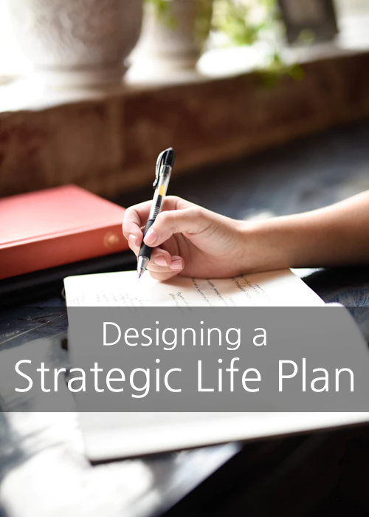

Designing a Strategic Life Plan to Live Your Best Life ©

VIP Innovations, LLC
https://www.vipinnovations.com

How intentional are you in your life?

If you’re not sure of the answer, you’re not alone. Most people already feel pretty bogged down by all the things they have to do in a day. Between work and personal responsibilities, there never seems to be time enough to do the things we’d really like to do, such as exercise more or change out a bad habit for something better. The last thing anyone needs is another dozen items on an already full To-Do List!

The problem is, it’s hard to be happy when all you’re doing is chasing after the status quo. But who has the energy to do anything else? No one likes the feeling of being stuck in inertia. The question then becomes, how do you still achieve more, without killing yourself in the process?

The answer lies in a Strategic Life Plan.

Designing a Strategic Life Plan can help you streamline your life so you can enjoy it more. It means deciding you and your goals are important enough to become intentional about them. It means taking control of your life, instead of your life pushing you around. Imagine how different a life like this would feel, and how much more energy you would have when it comes time to face your day. Imagine the stress of your daily life just melting away.

Let’s look at some tips for how to design a Strategic Life Plan so successful that you’ll actually be free to live your best life!

Start with Where You’ve Been
How can you possibly figure out where you’re going without a firm and honest assessment regarding what you’ve tried in the past already? You especially need to focus on what hasn’t been working, so you can determine the areas where you still need the most work.

Have a Firm Grasp of What You Believe?
Your Strategic Life Plan should reflect your values no matter what. Creating a plan to guide you when you’re unclear what those values are is just asking for confusion. Start by asking yourself what things in your life are the most important to you. What’s least important? What things would you like to do to reflect your values?

What’s the Long-Range Plan?
There are all kinds of goals. Some might be small, with the expectation that you’ll accomplish them reasonably soon. Others might take years to fall into place. By listing out all of your goals and putting them in order, you start to see the roadmap you’re going to be following in your Strategic Life Plan. If you’re not sure what your goals are, start by asking these questions:

- Where do I want to be next week? Next month? Next year?
- What do I see myself doing five years from now?
- Where would I like to be ten years from now?

What are the Logical Steps from Here?
To reach those goals, what are the steps linking them all together? Create a list of those steps. This will serve as your guide going forward. Don’t let a long list scare you. Challenging goals are going to be complex. Once you have each step written out, write only the ones you need to work on this week or this month on another sheet of paper. Keep that shorter list where you see it daily. Once those items are completed, create another short list from the master list. This will keep you focused on the big picture without bogging you down in limiting beliefs and fear.

Assess Failure
Chances are you’ve tried to reach some, if not all, of these goals before, with varying degrees of success. Your strategy should already have these life lessons built in. To consciously learn from your mistakes, start by asking what didn’t work for you. Examine how these roadblocks kept you from reaching your goals. Take time to understand and appreciate the lessons of the past, so you don’t make the same mistakes in the future

Create a Framework of Success
Frequently we can’t succeed alone, no matter how hard we try. Who are the people in your life able to help you the most along the way? Ask for support to fill those needs. At the same time, don’t forget to seek out mentors to guide and answer questions, and put in place whatever systems will make your changes easiest to attain (such as joining a gym or taking a class).

Understand What You’re Giving Up
Keep in mind, you can’t have everything. If you want to do one thing today, you’re very likely saying ‘no’ to something else. Take time to think about these compromises and ask yourself if these are things you can live with. If you can’t, you might need to reassess your strategy or even rethink the entire goal. Go back to your list of values. Maybe you simply need to reconsider the goal timeline or tweak how you want to accomplish the goal.

If You’re Multitasking, Be Clever About It
We all know that single-tasking gets more done, but there’s still something to be said for multitasking now and again. The smart strategist pairs up activities which flow well together, like exercising while listening to an audiobook, or talking on the phone while making dinner. The trick is to do something intellectual alongside something physical for the best success.

Find a Better Use of Your Time
There are some things only you can do when it comes to working to achieve your goals, but there are also aspects of your life anyone can do. Part of having a solid strategy is finding ways to delegate or even cut corners where you can. For example, would it be better to hire someone to mow the lawn when you could be spending that time taking action on your goal? What about grabbing something pre-made from the deli once in a while, rather than cooking from scratch every night? These chunks of time add up and can keep you from feeling overwhelmed by taking on a goal that’s important to you.

Clear the Decks
Remember how you were always rushing around putting our fires without getting anything significant done? Part of having a Strategic Life Plan lies in clearing out the dreck of what wastes your time. The simplest way? Take everything off your calendar and then start putting things back on in order of importance. Start with the stuff you can’t compromise, like your job, and go from there. You’ll soon figure out which things really just aren’t worth your time anymore.

Embrace the Idea of Imperfection
What needs to be done right, and what can just be ‘good enough’? If this question made you flinch, you might need to assess just how much perfectionism you’ve let creep into your life. The truth of the matter is, you very rarely need everything done ‘right.’ So, what if your home has that ‘lived-in look’? Take time to figure out what needs to be done right, and what just needs to be done. Your best strategy involves putting your most solid effort where it matters most. The rest can slide a little with little notice at all.

Keep Your Eye on the Prize
When designing your Strategic Life Plan, you may come up against hard decisions. When you’re not sure of the tradeoff, and the path seems somewhat muddied, it’s time to focus your gaze again on your long-term goals and ask which choice better aids you in achieving your dreams. This should clarify matters considerably. If not, try examining both opportunities and ask yourself honestly if either benefit you, or whether there might be a third option you hadn’t seen which would better serve your purpose.

Spend Time Organizing
It always seems somewhat counterproductive to take the time you could be using to get things done just to make a To-Do list or to muck about with a schedule. In truth, the time you spend now organizing is what’s going to keep you from putting in empty hours of work later on. All too often we tend to lose far too many hours in looking for materials or figuring out what we’re supposed to be doing next. Creating and managing a clear schedule is crucial to your Strategic Life Plan success.

Remember to Have Fun
When was the last time you gave yourself a break? Believe it or not, having a little fun time is absolutely necessary for a Strategic Life Plan. Driving yourself relentlessly forward only serves to wear you. Fatigue will strip whatever excitement you had for your goals. By working in some fun stuff and self-care, you allow yourself to reconnect with yourself. It also serves as a high relaxation point and recharges your energy to come at your projects again tomorrow.

The most important thing to keep in mind in creating a Strategic Life Plan is this: The very definition of the phrase sums up what should be your entire life going forward.

By being Strategic, you’re being intentional in what you’re going. You’re making all the decisions and are in control of your destiny. You’re no longer reacting to what’s going on around you. You’re creating direction, a goal, and a purpose.

By focusing on your Life, you’re saying this plan isn’t just for today or even this year. You’ve determined that you are important enough to examine your existence as a whole. You’re taking control of more than your schedule and seeing your destiny as one of happiness and health for years to come.

By creating a Plan, you’re making a roadmap to help you reach your goals. This isn’t just a random fluffy feel-good idea. What’s more amazing? This is something you have the power to accomplish.

_________________________________________

